**DAILY ONLINE ACTIVITIES SUMMARY**

|  |  |  |  |  |  |  |  |  |
| --- | --- | --- | --- | --- | --- | --- | --- | --- |
| **Date:** | **25/06/2020** | | | | | **Name:** | **NIKHIL KUMAR** | |
| **Sem & Sec** | **4thSEM. & ‘B’ SEC.** | | | | | **USN:** | **4AL19CS400** | |
| **Online Test Summary** | | | | | | | | |
| **Subject** | | **NIL** | | | | | | |
| **Max. Marks** | | **NIL** | | **Score** | | | **NIL** | |
| **Certification Course Summary** | | | | | | | | |
| **Course** | **Solid fundamental HTML, CSS, JavaScript Course** | | | | | | | |
| **Certificate Provider** | | | **BitDegree** | | **Duration** | | | **5hr** |
| **Coding Challenges** | | | | | | | | |
| **Problem Statement1 : write a c program to reverse the row in 2D Array.**  Given a 2D array arr[][] of size M x N integers where M is the number of rows and N is the number of columns. The task is to reverse every row of the given 2D array.  **Example:**  **Input:** arr[][] = { {1, 2, 3}, {4, 5, 6}, {7, 8, 9} } **Output:** 3 2 1 6 5 4 9 8 7  **Input:** arr[][] = { {1, 2}, {4, 5}, {7, 8}, {9, 10} } **Output:** 2 1 5 4 8 7 10 9 | | | | | | | | |
| **Status: Executed** | | | | | | | | |
| **Uploaded the report in Github** | | | | | **Yes** | | | |
| **If yes Repository name** | | | | | <https://github.com/Nikhil401/C-Coding/blob/master/Reverse2D.c> | | | |
| **Uploaded the report in slack** | | | | | **Yes** | | | |

**Online coding summary: Today I had received one program which is mentioned in table above and I have uploaded into the github repository. Snapshot of the program is given below:**

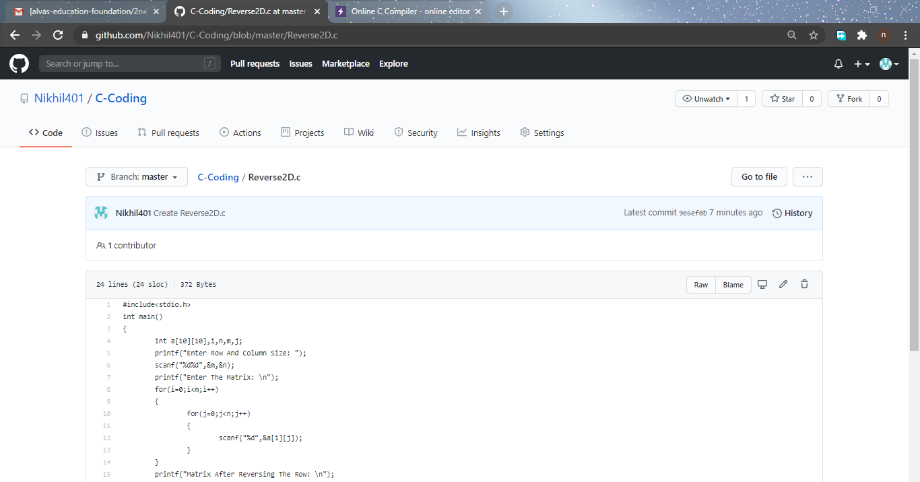

**Certification Course Summary: Today I have finished the certification course of “ Solid fundamental HTML, CSS, JavaScript Course” and the snapshot is given below:**

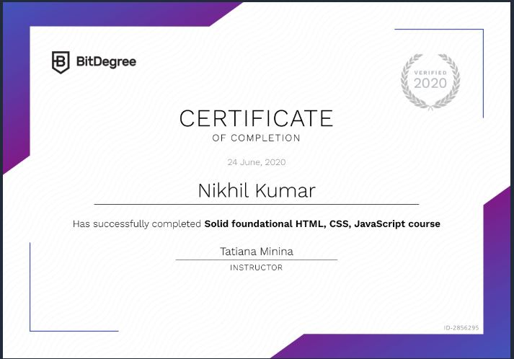

**Online Training : Today I had attended the online training organized by CSE Department AIET. The training was on C++,Introduction to oop, Feature done by prof. Sruthi Shetti J. CSE Dept. After the session the quiz was conducted.**

**The is the snapshot of the quiz attempted and obtained marks.**

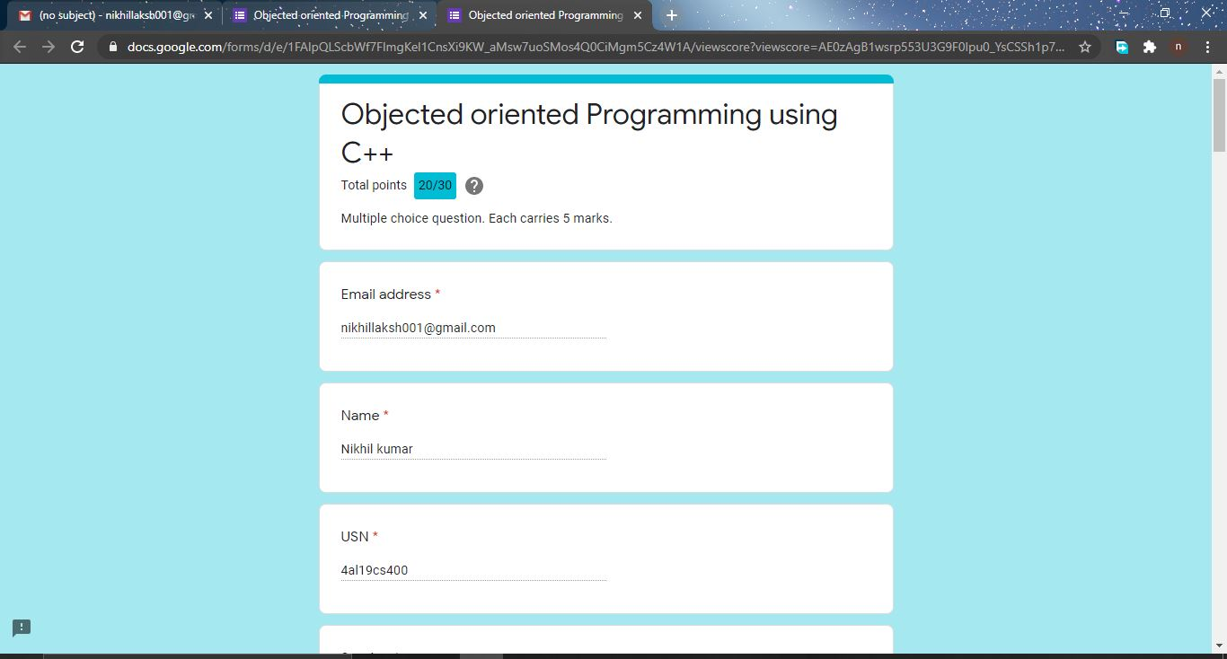**Thank you.**